MSLD63D

Solar Lantern LED Driver and SMF Battery Charger with 3 stage Dimming, mobile phone charging

|  |  |
| --- | --- |
| naming.png | **Product Features**   * High Efficiency * Constant Current LED driver * Three Stage Dimming – (300mA, 200 mA, 100 mA) * Input – 6V SMF/Lead Acid(5.25V to 6.5V) * 6V SMF/Lead Acid battery charger. * Output Voltage: Boost configuration * High and Low Voltage Cutoff – 5.25V and 6.5V * Energy Efficient – no power consumption during off mode * Battery Over Voltage Protection * Battery Reverse Charging Protection * Mobile Charger(O/P 6.0V, 150mA)   **Application**  MSLD63D is a high efficiency LED driver with SMF/Lead Acid battery Charging for 6V SMF battery and efficient three stage Dimming Control.  Its high/low voltage control, state of art protection circuit for Battery Reverse Charging and Battery Over Voltage.  This is best suited for designing of Solar Lanterns, powered with 6V SMF battery. It can drive LED string with output power 1W to 3W.  For best efficiency use 3 LEDs in series. |

Product Electrical Characteristics

LED Driver

|  |  |
| --- | --- |
| Input Voltage | 6V SMF/Lead Acid battery |
| Output Current | As per dimming stage selected |
| Output Voltage | As per dimming stage |
| Output Power | 1W to 3W |
| Dimming Control | Three Stage Dimming  Low – 100 mA current on load  Medium – 200 mA current on load  High – 300 mA current on load |

Mobile Charger

|  |  |
| --- | --- |
| Input Voltage | 6V SMF/Lead Acid battery |
| Output Current | I50mA |
| Output Voltage | 6V |
| Configuration | Constant Voltage Battery charger |

Connectors

MSLD63D is designed for solder free, easy installation. Design includes following connectors

1. CN1: 2 pin 2.5 mm Berge Pin male connector for connecting Solar Panel
2. CN2: 2 pin 2.5 mm Berge Pin male connector for connecting Battery
3. CN3: 2 pin relimate male connector for connecting LED string
4. CN4: 5 pin 2.5 mm Berge Pin male connector for connecting battery charging indicator led, low/high cutoff indicator led
5. CN5: 2 pin 2.5 mm Berge Pin male connector for connecting LED charging indicator
6. CN6: 6 pin 2.5 mm Berge Pin make connector for connecting Dimming Switch, power on/off button
7. CN7: To connect power supply/power switch for mobile charger

Connector Type: Berge Pin 2.5mm male

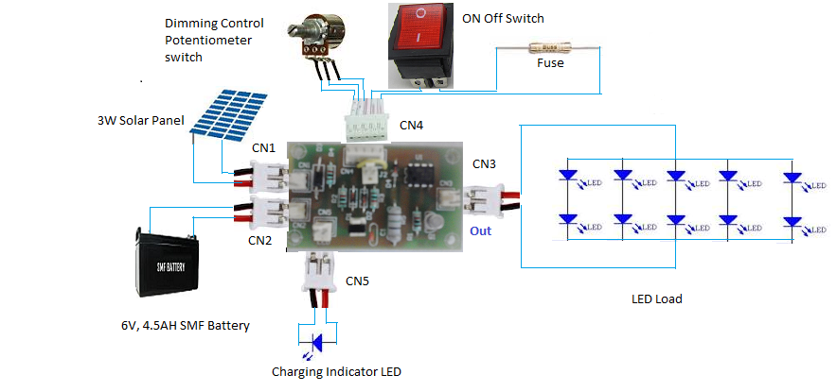

PCB Size/ Quality

MSLD63D is designed considering

* Compact PCB to fit properly in lantern designs
* Components sufficiently spaced for heat dissipation
* PCB is designed with high quality Phenolic material
* Connectors mounted on PCB are 2 pin and 5 pin berge pin make connector of 2.54 mm pitch
* PCB size is 3 inch * 2 inch

Mobile Charging

Separate small PCB for mobile charger is available. If required Mobile Charger can be integrated in same PCB

Mobile Charger output:

Voltage: 5 Volt

Current: upto 300 mA

Testing Details

**Test Setup**

MSLD63D is tested as Solar Lantern with following

|  |  |  |
| --- | --- | --- |
| LED Load | No of LED | 3 |
| Manufacturer | Osram |
| Model | LUW W5AM |
| Forward Current Rating | 350 mA |
| Forward Voltage | Min:2.7V Typ: 3.2V, Max: 3.7V |
| View Angle | 170 degree |
| Power Supply | DC regulated power supply | Voltage varied from 6.8V to 5.2V |
| Multi-meter | Manufacturer | Fluke 287 |

Test Results

**Current Regulation - Low Current (100mA)**

**Current Regulation - Medium Current (200mA)**

**Current Regulation - High Current (300mA)**

About Moxie Devices

Moxie Devices is a professionally managed company engaged in the designing, manufacturing, distribution and export of Solar energy and LED based Products for various applications. Our products exemplify TQI (Technology, Quality and Innovation). Our products are known for their enormous energy efficiency and reliable performance.

Our focus is to provide environmentally conscious solutions by creating products that are designed to meet unique customer needs and protect the environment for today and for the future.Moxie Devices is a professionally managed company engaged in the designing, manufacturing, distribution and export of Solar energy and LED based Products for various applications. Our products exemplify TQI (Technology, Quality and Innovation). Our products are known for their enormous energy efficiency and reliable performance

Information furnished is believed to be accurate and reliable. However, Moxie Devices Pvt. Ltd assumes no responsibility for the consequences of use of such information nor for any infringement of patents or other rights of third parties which may result from its use. No license is granted by implication or otherwise under any patent or patent rights of Moxie Devices Pvt. Ltd. Specification mentioned in this publication are subject to change without notice. This publication supersedes and replaces all information previously supplied. Moxie Devices Pvt. Ltd products are not authorized for use as critical components in life support devices or systems without express written approval of Moxie Devices Pvt. Ltd.

Moxie Devices Logo is a trade mark of Moxie Devices Pvt. Ltd.

Printed in India – All rights reserved